# How to use the Public Health Impact Measures

## **Guidance for Birmingham’s Neighbourhood Network Schemes**

## Introduction

This guidance is intended to assist community organisations using an Impact Measure as a condition of their Neighbourhood Network Scheme grant funding. This guide is also written for the Neighbourhood Network Scheme (NNS), who will be supporting community organisations to use these Impact Measurement tools.

We want to support community organisations with the additional work involved in using these Impact Measures. We can offer training and support, and please also discuss with your NNS Team how they can support you.

## What is Covered by this Guidance?

* Description of the measures.
* Why and how we are using them (and limitations).
* Step-by-step instructions on how to use each Impact Measure, how to calculate the score achieved by each citizen and how to report this data.
* Why we need your help to capture the learning from implementing Impact Measures in your community project.

This guidance should be looked at in conjunction with the Impact Measurement tools / questionnaires. Your local NNS can provide copies of these.

**Please note that this guidance is not written for citizens participating in projects;** we have a separate information sheet which will help projects to explain key points to citizens.

## What are the Public Health Impact Measures?

Public Health has put together a toolbox of **validated Impact Measures[1]** for activities that aim to improve health and wellbeing across Birmingham. The aim is to standardise measures used, to provide clarity and transparency, and enable accurate and meaningful assessment against KPIs. You can find the toolbox here: [Birmingham Public Health Measurements Toolbox](https://www.birmingham.gov.uk/info/50321/birmingham_public_health_measurements_toolbox)

Using the Impact Measures will demonstrate the positive contribution that your organisation’s project (and the NNS) is making to the health and wellbeing of Birmingham’s older citizens, and younger disabled adults.

We are implementing the measures in 2025 due to a new funding agreement between BCC’s Adult Social Care and Public Health Birmingham. The funding contributed by PH goes towards NNS grants so this is how we will demonstrate the impact.

The table below shows the measures and how they align to 5 Key Performance Indicators (KPI’s) from our agreement with Public Health.

|  |  |
| --- | --- |
| **Validated Impact Measure** | **Key Performance Indicator (KPI)** |
| 30-Second Chair Stand Test | % Improvement in 30 second sit to stand test |
| Mental Health Wellbeing Questionnaire (WEMWBS) | % increase in Wellbeing by 3 or more points on WEMWBS 14-point scale |
| Social Isolation Tool (The three-item UCLA loneliness scale) | % not self-reporting loneliness |
| Nutrition Toolkit | % self-reporting an increase in nutritional understanding |
| All Aspects of Health Literacy Questionnaire (AAHLS) | % self-reporting an increase in health literacy |

## Which NNS funded Projects need to use a Public Health Impact Measure?

## Projects awarded an NNS grant of £5000 or more.*

1. Types of project activities in scope:
   1. social participation,
   2. healthier lifestyles (physical, mental, and social)
   3. carers support​
2. Types of project activity excluded:
   1. General information advice and guidance / income maximisation​ services
   2. Independence at home, such as minor repairs and garden clearance.

*\*Optional for projects awarded under £5000.*

With support of the NNS Team **each eligible project will be asked to use one Impact Measure, which best fits their project.**

**Please Note -** These validated Impact Measures are in addition to the existing reporting required by your local NNS Team.

Impact data can be used to support applications or reporting to other funders.

## What are the limitations?

The Impact Measurement tools set out in this guidance are selected by Public Health (PH) as the best fit for gathering data against each of the KPI’s. Therefore, you can only use **one** of the Impact Measures listed in this guidance.

We know that if you do a variety of activities, you could use two or more of the measures, but initially we want you to choose just **one Impact Measurement tool** for each NNS funded project. As confidence grows, we will open the option to complete more than one tool.

We understand that the measurement tools are broad quantitative measures and as such they only ‘scratch the surface’ of all the amazing things you do in your projects. We know that it’s the 'distance travelled' that’s important, not where you arrive, and that for many citizens the achievement is in maintaining their health and wellbeing, rather than improving.

However, the measures do really help to demonstrate to funders, and partner organisations, how activities like yours can help improve citizens health and wellbeing. We will continue to work with Public Health to improve the tools available.

We recognise that some citizens may complete a first measure and then not be available to complete the second measure. There are lots of different reasons for this, over which community organisations have no control. Unfortunately, this means we cannot use that particular citizen’s data, since only a first and second measure will demonstrate any change. However, other methods that projects are using to report to the NNS will compensate for this and ensure their experience is not excluded.

The Impact Measure questionnaires might be challenging for citizens for whom English is not their first language or who need information in an accessible format. If this is the situation with citizens you support, then please raise your concerns with your local NNS team. Our understanding is that we are not permitted to amend the questions. We will be looking for solutions to this with PH.

We hope that all the community projects applying for an NNS grant, and fitting the criteria above, will be able to pick one of the Impact Measures that best fits their project. However, we accept that for some projects this may not be possible. If this is the case, please ensure you have discussed this with your NNS worker.

We are aware that NNS teams and community organisations are also involved in the **Fairer Futures Fund**, which requires Impact Measurement tools from the Public Health Toolbox [there is a link to PH’s toolbox in the introduction]. We will share learning where we can.

# INSTRUCTIONS FOR EACH VALIDATED IMPACT MEASURE

Community organisations will have agreed with the NNS Team which of the Impact Measures they will use before they submitted a grant application. At this point, the local NNS Team will provide applicants with all the relevant documents for their chosen Impact Measure.

Remember that your NNS can support you with using these measures and is the first point of contact for any queries. Although we are not able to amend the questionnaires, we will try to support where we can with accessibility needs, e.g., questionnaires in large font.

Community organisations should be sensitive to the needs of citizens willing to complete an Impact Measure. Some of the questions could trigger difficult feelings. We understand that resources are limited but where possible, consideration should be given to whether people need more time, privacy, or a calmer environment; or time to talk afterwards if they need to. For some citizens the process of completing the questionnaires, or test, might raise concerns about their health or mental wellbeing. In which case they should be encouraged to discuss with their GP or other appropriate health professionals.

The results of the questionnaires and the change between the two scores can be shared with citizens. **Please be aware that citizens must answer all the questions in each Impact Measure if they don't the result won't be valid.**

## Social Isolation Tool (The three-item UCLA loneliness scale)

*The scores for each individual question can be added together to give you a possible range of scores from 3 to 9. Researchers in the past have grouped people who score 3 to 5 as 'not lonely' and people with a score 6 to 9 as 'lonely'.*

* *Often = 3*
* *Some of the time = 2*
* *Hardly Ever =1*

*Individuals who are experiencing levels of companionship lower than they desire should be assisted with achieving this, depending on the organisation or intervention. Desired levels of companionship will change depending on the person, this should always be considered in approaching the questionnaire and results.*

## Nutrition Toolkit

*The Nutrition Toolkit is designed to check a citizen’s confidence in relation to aspects of healthy eating.*

*On the scale of 1-5, 1 is ‘not at all confident’ and 5 is ‘extremely confident’.*

*Advice and assurance should be given to individuals to increase their confidence, depending on the organisation or intervention.*

*The minimum scores a citizen can achieve is 5 and the maximum score is 25.*

## All Aspects of Health Literacy Scale (AAHLS)

*As set out below each answer has a numerical value. Once the form is complete, add up the total score and record in the “Citizen’s Total Score” box at the bottom of page 2. When adding up the score, please note that ‘Often’ sometimes scores a [1] and for other questions a [3]. Citizens could increase their total ‘health literacy’ scores in the following way:*

* *Questions FQ1-3 –* ***Reduce*** *number of ‘often’ answers (Scored as: Often=1 / Rarely=3)*
* *Questions ComQ1-3 –* ***Increased*** *number of ‘often’ answers (Scored as: Often=3 / Rarely=1)*
* *Questions Cr1-3 –* ***Reduce*** *number of rarely (Scored as: Often=3 / Rarely=1)*
* *Emp 2 –* ***Move*** *from No to Yes (Scored as: Yes=3 / No=1)*

## Mental Health Wellbeing Questionnaire – WEMWBS

* *Before you use the WEMWBS you will need to register for a license from University of Warwick Medical School. It is free for non-commercial use. Please use the link below. https://warwick.ac.uk/fac/sci/med/research/platform/wemwbs/using/non-commercial-licence-registration/*
* ***Frequency:*** *Measurements should be taken at baseline (pre-intervention) and at follow-up. As the questionnaire asks about the participants’ previous two weeks, the second follow-up measurement should take place at least two weeks after first (baseline) measurement.*
* ***Scoring:*** *A total score is simply obtained by adding up the scores for each of the 14 questions. The scoring range for each item is from 1 – 5. The lowest total score is 14, whilst the highest total score is 70. We want to know the difference in the overall score and the measure of an effective change is an increase by 3 or more points.*

## 30-Second Chair Stand Test

**Please note that a member of staff will need to conduct this test, for safety reasons a citizen should not be expected to self-administer this test.**

**If you think the citizen at risk of a fall or injury during the test, please do not use this tool. In the first instance, you should discuss any concerns with your local NNS.** We also acknowledge that this test is not suitable for groups where standing is limited or not possible and encourage these groups to explore the option of completing the Social Inclusion and/or WEMWBS tools as an alternative while we explore more suitable tools with PH.

***Overview:*** *The 30-Second Sit-to-Stand test can be used by all age ranges to measure lower body and core body strength, however, it was originally developed to be used with individuals that are predominantly:*

* *Adults over 40*
* *Older Adults (65+)*
* *Adults with a physical condition that may limit their ability to engage with strenuous activity.*
* *Groups that deliver indoor activity and/or less aerobic activity*

*Groups that don’t meet the above criteria may still decide to use the 30-Second Sit-to-Stand test.*

***Purpose:*** *To test leg strength and endurance:*

***Equipment:*** *A chair with a straight back and without arm rests,* ***placed against a wall to prevent it moving.*** *A stopwatch/timer*

***Note*** *– the citizen may wish to conduct this test in a private or separate space as they may feel uncomfortable with other citizens watching.*

*Count the number of times the citizen comes to a full standing position in 30 seconds and record it in the box at the bottom of the sheet we have provided. If the citizen is over halfway to a standing position when 30 seconds have elapsed, count it as a stand. If the citizen must use his or her arms to push up to a stand, then stop the test and record “0” for the test. If the participant is over halfway to a standing position when 30 seconds have elapsed, count it as a stand.*

*Please remember that this is purely Public Health's 'benchmark' for this impact measure. No-one should feel discouraged by these categories or under pressure to move from one category to another.*

***Chair Stand – Number of stands by age group and gender.***

|  |  |  |  |
| --- | --- | --- | --- |
| **Men** |  |  |  |
| **Age Group (years)** | **Below Average** | **Average** | **Above Average** |
| 18-24 | <16 | 16-21 | >21 |
| 25-39 | <16 | 16-21 | >21 |
| 40-59 | <16 | 16-21 | >21 |
| 60-64 | <14 | 14-19 | >19 |
| 65-69 | <12 | 12-18 | >18 |
| 70-74 | <12 | 12-17 | >17 |
| 75-79 | <11 | 11-17 | >17 |
| 80-84 | <10 | 10-15 | >15 |
| 85-89 | <8 | 8-14 | >14 |
| 90 and over | <7 | 7-12 | >12 |

|  |  |  |  |  |  |  |
| --- | --- | --- | --- | --- | --- | --- |
| **Women** |  | |  | | |  |
| **Age Group (years)** | | **Below Average** | | **Average** | **Above Average** | |
| 18-24 | | <14 | | 14-19 | >19 | |
| 25-39 | | <14 | | 14-19 | >19 | |
| 40-59 | | <14 | | 14-19 | >19 | |
| 60-64 | | <12 | | 12-17 | >17 | |
| 65-69 | | <11 | | 11-16 | >16 | |
| 70-74 | | <10 | | 10-15 | >15 | |
| 75-79 | | <10 | | 10-15 | >15 | |
| 80-84 | | <9 | | 9-14 | >14 | |
| 85-89 | | <8 | | 8-13 | >13 | |
| 90 and over | | <4 | | 4-11 | >11 | |

**INSTRUCTIONS FOR RECORDING AND REPORTING OF DATA**

# Privacy and data protection when recording and reporting.

We are committed to safeguarding the confidentiality and integrity of all personal data, as we know you are. When reporting and returning data to us, we ask that you do not use citizens’ names (or any other naming convention which might allow an individual to be identified). Please only use a unique number assigned to each individual citizen. Please ensure you store all personal citizen data on your own system in line with your data and security policies.

# Recording citizen information using the questionnaires/data collection sheets.

Citizens will need to complete the chosen questionnaire or test twice; this is to allow for any changes to be measured. Please encourage as many citizens as possible to complete a questionnaire. However, we understand that citizens may be reluctant or unable to complete the questionnaire in its current form. We will provide a **learning log** to record what goes well as well as the challenges, see the section below on ‘Capturing the Learning’. Please provide as much detail as you can, this will help us improve accessibility in the future.

Once you have the completed questionnaires, you can enter the results onto a **data collection sheet. Each data collection sheet is specific to a questionnaires or tests.** These are Microsoft Excel spreadsheets which have been set up to do all the calculations for you. They will calculate the change between the first score and the subsequent score for each citizen, the % change for the project / activity and any further calculations required to meet the Public Health benchmark.

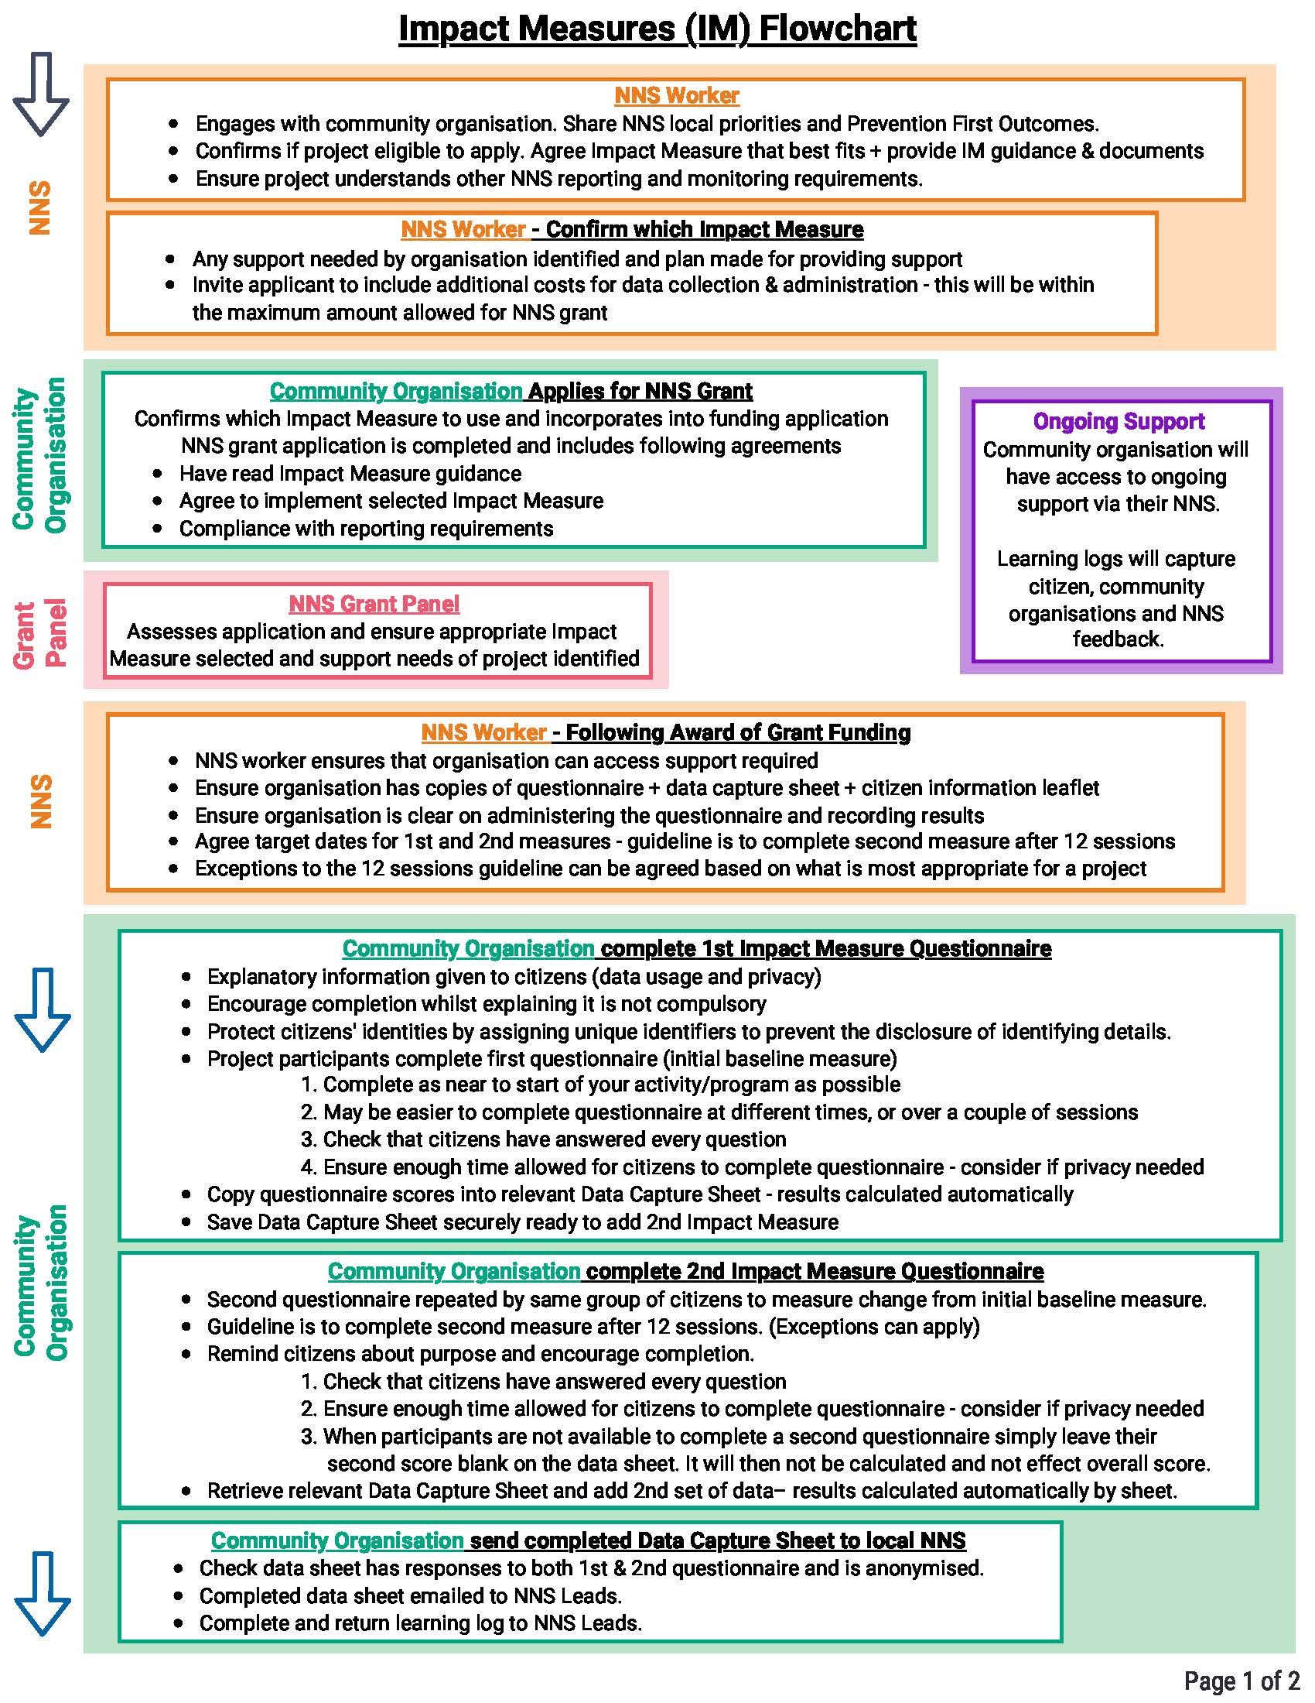**FLOWCHART: STEP BY STEP PROCESS**

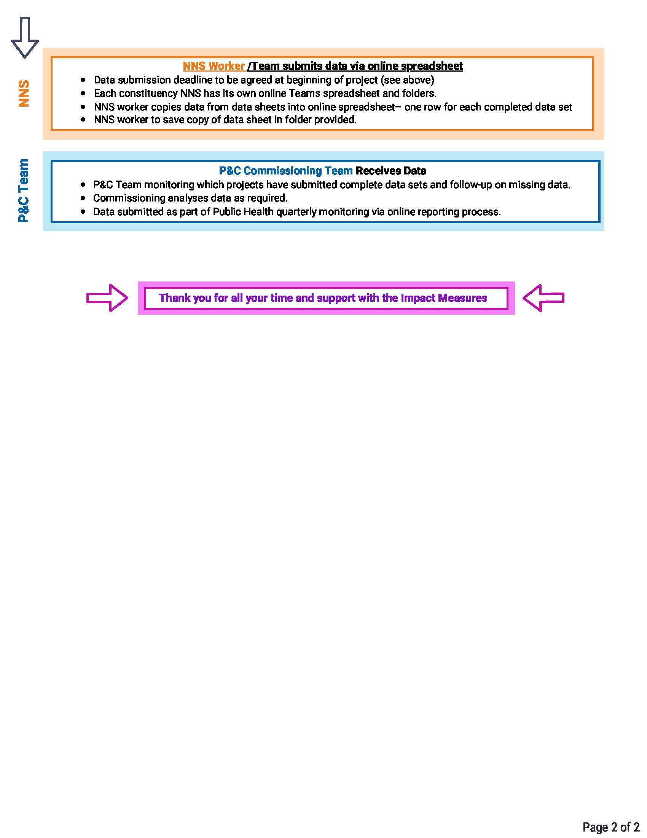

# CAPTURING THE LEARNING

We understand that using validated Impact Measures and capturing data from the citizens you support may be new to some community projects, or that you may have concerns about aspects of this process.

We would really like to hear feedback on this experience. We want to understand which Impact Measures work well and which don’t, and the reasons for this. We want to hear your queries or concerns about any aspects of the process, and of course any ‘top tips’ you’re able to share. We’ve have provided a **Learning Log** template for you to complete. Your NNS team may contact you at any point to ask you to share your experiences so if you can update it regularly that would really help us. You should send any updates to your learning logs to your local NNS team who will then forward to BVSC or the Commissioning Team.

Returning these will help us to improve our processes and guidance and work with Public Health on improving the measures.

If you have any questions or concerns around the data collection or recording, please contact your NNS. It is helpful if you can note of any comments or feedback you have in the learning log.

____________________________

On behalf of the Prevention and Communities Commissioning Team we’d like to thank everyone involved for your support and commitment to this process.

**Matthew Bick, Lise Smith & Jordan Page**

1. A validated Impact Measure is a survey or screening questionnaire that has been tested to ensure production of reliable, accurate results.